A Project report on
Hospital Management Database
A Relational Database System for Automated Hospital Administration
Group Members | Madhav Narang — Roll No. 1024170287 (2Q33)
 | Piyush — Roll No. 1024170371 (2Q33)
 | Madhav — Roll No. 1024170356 (2Q33)
Lab Instructor
Academic Year | 2025 – 2026


DEPARTMENT OF COMPUTER SCIENCE AND ENGINEERING
THAPAR UNIVERSITY
INDIA
Session-Year: Jan-May, 2026

1. Introduction

1.1 Application Domain
Hospital Management Database is a backend relational database system designed to manage the critical data generated by a modern hospital — covering patients, doctors, room allocations, appointment scheduling, and billing. The application domain encompasses every administrative and clinical event a hospital encounters, from the moment a patient is registered to the moment their bill is settled and their appointment history is archived.

1.2 Motivation for Selecting the Problem
Hospitals across India process thousands of appointments, admissions, and billing transactions daily. Behind every visible clinical interaction — registering a patient, booking a doctor appointment, assigning a room, or generating a bill — lies a complex relational data model that must remain consistent, accurate, and fully recoverable. Traditional paper-based or spreadsheet approaches fail to maintain this scale of correctness and availability. This project demonstrates how a properly-designed Database Management System provides the structural backbone for hospital administration, delivering data integrity, automation, and transactional safety that manual systems cannot offer.

1.3 Importance of DBMS over File-Based Systems
- Data Redundancy: Patient profiles, doctor records, and appointment details are stored exactly once and referenced via foreign keys. A flat-file system would duplicate the same patient data across every appointment, billing, and room record.
- Data Integrity: Constraints (NOT NULL, UNIQUE, CHECK, FOREIGN KEY) enforce business rules at the database level — for example, patient age must be between 1 and 120, and an appointment cannot reference a non-existent doctor.
- Concurrent Access: Multiple staff members can register patients and book appointments simultaneously without corrupting data, thanks to MySQL row-level locking — impossible with file-based systems.
- Transactional Consistency: Multi-step operations such as creating an appointment and updating the room status are wrapped in COMMIT/ROLLBACK blocks, guaranteeing ACID compliance.
- Efficient Querying: Complex reporting queries — such as all unpaid bills, appointment details by doctor, or room occupancy status — can be answered using SQL JOINs and views in milliseconds.
- Automation: Views like appointment_details and unpaid_bills automate critical reporting queries, reducing manual aggregation overhead for hospital administrators.

2. Problem Statement

2.1 Real-World Problem
Hospitals and clinics generate large volumes of transactional data every day. Without a centralised, well-designed database, patient records become fragmented across paper files, spreadsheets, and standalone billing software. Tracking a patient's complete appointment history, calculating outstanding bills, monitoring room availability, and assigning the correct doctor becomes virtually impossible at scale. The absence of a unified data layer leads to incorrect billing, double-booking of doctors, lost appointment records, and inconsistent patient data.

2.2 Limitations of the Existing / Manual System
- No centralised data store — patient, doctor, and appointment information lives in disconnected registers.
- No automated room tracking — room allocation requires manual status updates, leading to double-occupancy errors.
- No real-time validation — incorrect blood groups, invalid appointment statuses, or out-of-range ages go undetected.
- No transactional safety — if an appointment insert succeeds but the billing step fails, data is left in a partial state.
- No automated reporting — generating a list of unpaid bills or upcoming appointments requires tedious manual aggregation.
- No referential integrity — manual systems can have orphaned bills pointing to deleted patients.

2.3 Scope of Database Usage in Solving the Problem
The proposed database stores all hospital entities (patients, doctors, rooms, appointments, bills) in normalised relational tables governed by foreign-key relationships. Views simplify complex reporting queries. Constraints automate data validation at the schema level. Together these components transform a fragmented manual workflow into a reliable, consistent, and auditable hospital information system.

3. Objectives of the Project
- To design a comprehensive hospital database using Entity-Relationship (E-R) data modelling, identifying entities, attributes, relationships, and cardinality constraints relevant to hospital administration.
- To convert the ER model into relational tables and apply normalisation up to Third Normal Form (3NF), eliminating redundancy and transitive dependencies across all five tables.
- To implement the relational schema using SQL DDL commands and populate it with DML operations, enforcing data integrity through PRIMARY KEY, FOREIGN KEY, UNIQUE, NOT NULL, CHECK, and ENUM constraints.
- To create database views (appointment_details, unpaid_bills) that simplify complex multi-table reporting queries into reusable SELECT statements.
- To build a Node.js + Express.js server layer that exposes RESTful API endpoints for CRUD operations on all five tables, enabling a full-stack hospital management application.
- To demonstrate efficient querying using SQL JOINs across multiple tables, ENUM-based status tracking, and aggregate functions for billing and appointment analytics.

4. Scope of the Project

4.1 Functional Boundaries
- Patient registration and profile management with blood group and contact tracking.
- Doctor management with specialty, phone, and email contact records.
- Room management with type classification (General, ICU, Private) and real-time availability status.
- Appointment scheduling linking patients to doctors with date, reason, and status tracking through three states (Scheduled, Completed, Cancelled).
- Billing management with payment status tracking (Paid / Unpaid) for each patient.
- Automated reporting views for appointment details and unpaid bill monitoring.

4.2 Types of Users Involved
User Role | Description | Access Level
Admin | Manages all hospital records, system reports, and user accounts | Full read/write on all tables
Receptionist | Registers patients, books appointments, manages billing | Read/write on patients, appointments, bills
Doctor | Views own appointments and updates status on completion | Read own appointments; update status

4.3 Modules Covered (Backend Focus)
Module | Database Objects Used
Patient Management | patients table, ENUM constraints, CHECK age 1-120
Doctor Management | doctors table, UNIQUE email, specialty field
Room Management | rooms table, ENUM type/status, UNIQUE room number
Appointment Scheduling | appointments table, FK patient_id + doctor_id, ENUM status
Billing | bills table, FK patient_id, CHECK amount >= 0, ENUM paid
Reporting & Analytics | appointment_details view, unpaid_bills view, JOINs

5. Proposed System Description

5.1 Overall Working of the Proposed Database System
The Hospital Management Database serves as the centralised backend for managing patient records, doctor profiles, room allocations, appointment scheduling, and billing operations. The system is composed of five normalised tables linked through foreign key relationships and two SQL views that simplify complex reporting queries.
When a patient is registered, their profile is inserted into the patients table with validated ENUM constraints on gender and blood group. A receptionist then creates an appointment record linking a patient to a doctor, with the date, reason, and status tracked through the appointments table. Rooms are managed independently through the rooms table, with status toggled between Available and Occupied as patients are admitted. Billing is handled through the bills table, which links each bill to a patient via a foreign key and tracks payment status.

5.2 Key Features and Functionalities
- Strict ENUM Validation: Gender, blood group, room type, room status, appointment status, and billing status are all enforced using ENUM columns — preventing invalid data at the schema level without application-layer logic.
- Referential Integrity via FK: The appointments table uses ON DELETE CASCADE for both patient_id and doctor_id. The bills table uses ON DELETE CASCADE for patient_id — ensuring no orphaned records remain when a patient is removed.
- Age Range Enforcement: The CHECK (age BETWEEN 1 AND 120) constraint in the patients table blocks biologically invalid entries at the database level.
- Appointment Details View: The appointment_details view joins appointments, patients, and doctors — enabling complex reporting (patient name, phone, doctor name, specialty, appointment date and reason) via a simple SELECT.
- Unpaid Bills View: The unpaid_bills view filters the bills table and joins with patients — giving administrators an instant dashboard of all outstanding payments without writing a JOIN query each time.
- Node.js REST API: The server.js layer exposes RESTful endpoints for all CRUD operations on each table, connecting the MySQL database to a browser-based HTML frontend.

5.3 How the System Improves Efficiency and Consistency
- Efficiency: Pre-built views and indexed primary/foreign keys reduce query latency. Reporting on appointments or unpaid bills requires a single SELECT rather than complex multi-table JOINs each time.
- Consistency: ENUM constraints, NOT NULL requirements, UNIQUE keys, and CHECK constraints enforce business rules at the schema level — guaranteeing no invalid state can be inserted regardless of the application layer.

6. Database Design

6.1 Entity-Relationship (ER) Diagram
Entities Identified
Entity | Description
Patient | Registered individuals seeking medical services at the hospital
Doctor | Medical professionals with a defined specialty, phone, and email contact
Room | Hospital rooms classified as General, ICU, or Private with live availability status
Appointment | Scheduled or completed clinical interactions between a patient and a doctor
Bill | Financial record for each patient tracking amount owed and payment status

Relationships and Cardinality
Parent Entity | Child Entity | Type | On Delete
Patient | Appointment | 1 : M | CASCADE
Doctor | Appointment | 1 : M | CASCADE
Patient | Bill | 1 : M | CASCADE
Room | (Appointment / Admission) | 1 : M | N/A

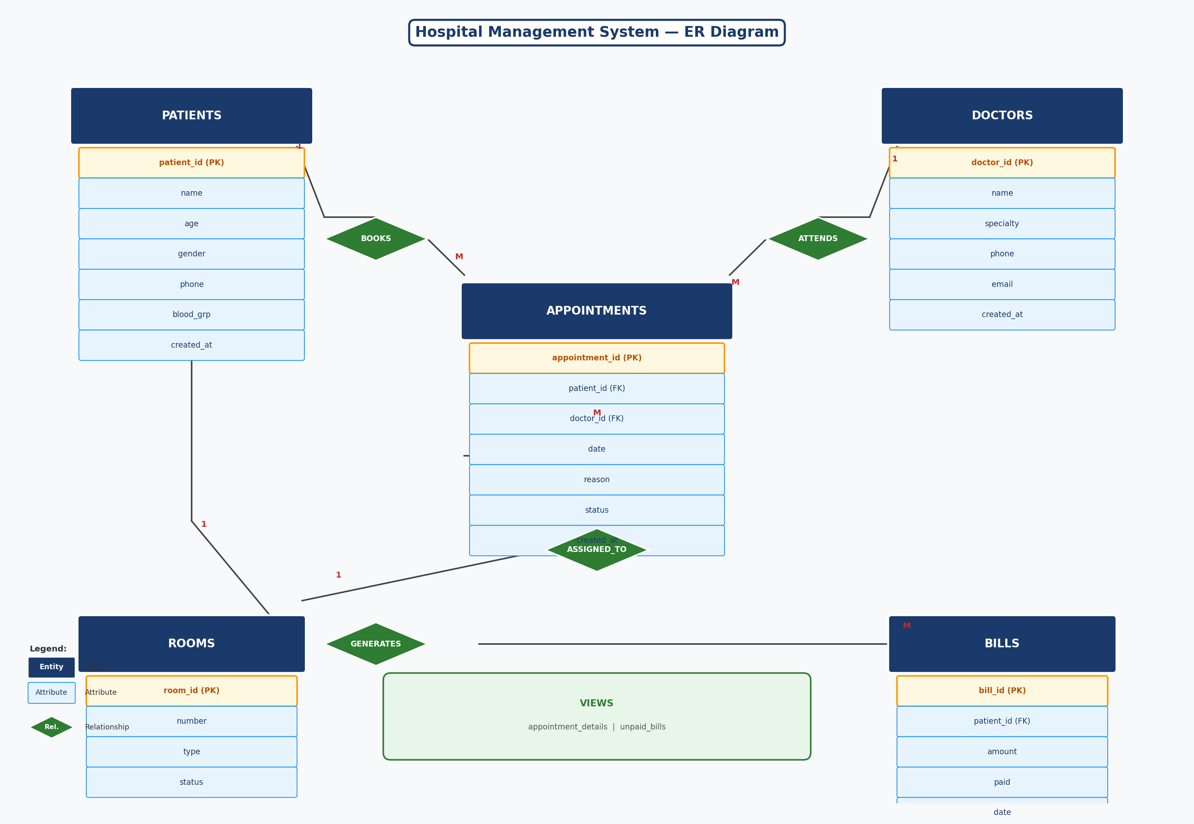
Figure 1 — Entity-Relationship Diagram

6.2 Relational Schema
Each entity from the ER diagram is converted into a relational table. Primary keys are auto-generated using AUTO_INCREMENT. Foreign keys enforce referential integrity with ON DELETE CASCADE across the schema.
patients ( patient_id PK, name, age, gender, phone UNIQUE, blood_grp, created_at )
doctors ( doctor_id PK, name, specialty, phone UNIQUE, email UNIQUE, created_at )
rooms ( room_id PK, number UNIQUE, type, status )
appointments ( appointment_id PK, patient_id FK, doctor_id FK, date, reason, status, created_at )
bills ( bill_id PK, patient_id FK, amount, paid, date )

7. SQL Implementation

7.1 DDL — CREATE TABLE Statements
The following SQL DDL commands create the five core tables with all integrity constraints:
CREATE TABLE patients (
id INT AUTO_INCREMENT PRIMARY KEY,
name VARCHAR(100) NOT NULL,
age INT NOT NULL CHECK (age BETWEEN 1 AND 120),
gender ENUM('Male','Female','Other') NOT NULL,
phone CHAR(10) UNIQUE NOT NULL,
blood_grp ENUM('A+','A-','B+','B-','AB+','AB-','O+','O-'),
created_at TIMESTAMP DEFAULT CURRENT_TIMESTAMP
);

CREATE TABLE doctors (
id INT AUTO_INCREMENT PRIMARY KEY,
name VARCHAR(100) NOT NULL,
specialty VARCHAR(100) NOT NULL,
phone CHAR(10) UNIQUE NOT NULL,
email VARCHAR(100) UNIQUE,
created_at TIMESTAMP DEFAULT CURRENT_TIMESTAMP
);

CREATE TABLE rooms (
id INT AUTO_INCREMENT PRIMARY KEY,
number VARCHAR(10) UNIQUE NOT NULL,
type ENUM('General','ICU','Private') NOT NULL,
status ENUM('Available','Occupied') DEFAULT 'Available'
);

CREATE TABLE appointments (
id INT AUTO_INCREMENT PRIMARY KEY,
patient_id INT NOT NULL,
doctor_id INT NOT NULL,
date DATE NOT NULL,
reason VARCHAR(200) NOT NULL,
status ENUM('Scheduled','Completed','Cancelled') DEFAULT 'Scheduled',
created_at TIMESTAMP DEFAULT CURRENT_TIMESTAMP,
FOREIGN KEY (patient_id) REFERENCES patients(id) ON DELETE CASCADE,
FOREIGN KEY (doctor_id) REFERENCES doctors(id) ON DELETE CASCADE
);

CREATE TABLE bills (
id INT AUTO_INCREMENT PRIMARY KEY,
patient_id INT NOT NULL,
amount DECIMAL(10,2) NOT NULL CHECK (amount >= 0),
paid ENUM('Paid','Unpaid') DEFAULT 'Unpaid',
date DATE DEFAULT (CURRENT_DATE),
FOREIGN KEY (patient_id) REFERENCES patients(id) ON DELETE CASCADE
);

7.2 Views
Two views are created to simplify repeated reporting queries:
CREATE VIEW appointment_details AS
SELECT a.id, p.name AS patient, p.phone AS patient_phone,
d.name AS doctor, d.specialty,
a.date, a.reason, a.status
FROM appointments a
JOIN patients p ON a.patient_id = p.id
JOIN doctors d ON a.doctor_id = d.id;

CREATE VIEW unpaid_bills AS
SELECT b.id, p.name AS patient, b.amount, b.date
FROM bills b
JOIN patients p ON b.patient_id = p.id
WHERE b.paid = 'Unpaid';

8. Technology Stack
Layer | Technology | Role
Database | MySQL | Relational data store with full constraint support
Backend | Node.js + Express.js | RESTful API server exposing CRUD endpoints
Frontend | HTML / CSS / JS | Browser-based management interface (public/ folder)
DB Connector | mysql2 npm package | Connects Node.js server to MySQL database

8.1 System Architecture
The application follows a three-tier architecture. The presentation layer (public/ HTML files) communicates with the application layer (server.js Express routes) via HTTP requests. The application layer in turn executes parameterised SQL queries against the MySQL database layer using the mysql2 package. This separation ensures that the database schema remains independent of the frontend interface, allowing either layer to be replaced without affecting the other.
To run the application: install Node.js, import hospital.sql into MySQL, configure database credentials in server.js, and execute node server.js. The server starts on localhost:3000 and exposes REST endpoints for all five entities.

9. Conclusion
The Hospital Management Database successfully demonstrates how a well-designed relational database can transform fragmented manual hospital record-keeping into a consistent, automated, and auditable information system. By applying entity-relationship modelling, normalisation to 3NF, ENUM-based constraint enforcement, foreign key integrity, and pre-built reporting views, the project addresses every limitation of manual or file-based hospital administration.
The five-table schema captures the full lifecycle of a hospital interaction — from patient registration and doctor assignment through appointment scheduling to billing resolution. The two reporting views (appointment_details and unpaid_bills) provide hospital administrators with instant, accurate dashboards without requiring manual query composition.
The full-stack implementation using Node.js and Express.js demonstrates how a MySQL database can be exposed as a REST API, enabling a practical browser-based hospital management interface. This project reinforces the foundational DBMS principles of data independence, referential integrity, and transactional consistency in a real-world healthcare context.

